EX NO: 4 | NETWORK PROGRAMMING

AIM:
To implement a simple Client–Server communication using TCP Socket Programming in Python.
PROGRAM(Server.py):
# ---------------------------------------------------------
# Server Program for TCP Communication
# ---------------------------------------------------------
# Importing socket module
import socket
# Create a socket object using IPv4 and TCP protocol
server_socket = socket.socket(socket.AF_INET, socket.SOCK_STREAM)
# Bind the socket to host and port number
host = "127.0.0.1" # Localhost
port = 5000 # Port number
server_socket.bind((host, port))
# Listen for incoming client connections
server_socket.listen(1)
print("Server is waiting for connection...")
# Accept the connection from client
client_socket, address = server_socket.accept()
print("Connection established with:", address)
# Receive message from client
message = client_socket.recv(1024).decode()
print("Message received from client:", message)
# Send response back to client
response = "Hello Client, Message received!"
client_socket.send(response.encode())
# Close the connection
client_socket.close()
server_socket.close()

PROGRAM(Client.py)
# ---------------------------------------------------------
# Client Program for TCP Communication
# ---------------------------------------------------------

# Importing socket module
import socket

# Create a socket object using IPv4 and TCP protocol
client_socket = socket.socket(socket.AF_INET, socket.SOCK_STREAM)

# Define server address and port
host = "127.0.0.1" # Localhost
port = 5000 # Same port as server

# Connect to the server
client_socket.connect((host, port))

# Send message to server
message = "Hello Server!"
client_socket.send(message.encode())

# Receive response from server
response = client_socket.recv(1024).decode()
print("Message received from server:", response)

# Close the connection
client_socket.close()

OUTPUT:
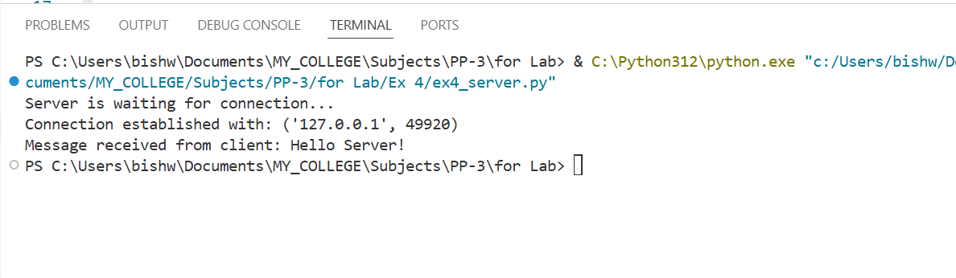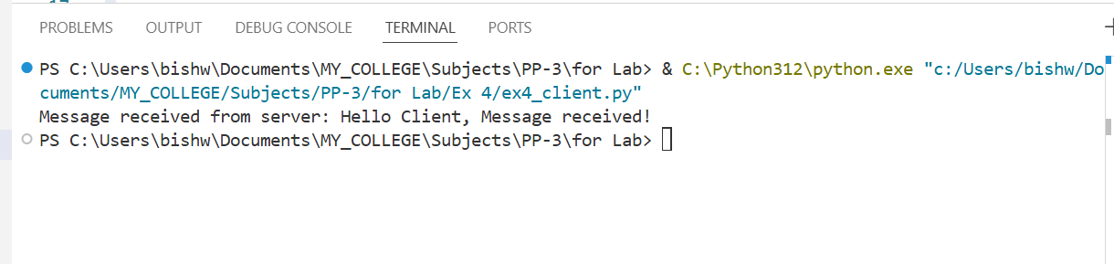

RESULT:
Thus, the Client–Server communication using TCP Socket Programming was successfully implemented and executed. The client was able to send a message to the server, and the server successfully responded back.

